

Customer Retention



Submitted by:

Rahul Singh

**ACKNOWLEDGMENT**

Thanks for giving me the opportunity to work in FlipRobo Technologies as Intern and would like to express my gratitude to Data Trained Institute as well for trained me in Data Science Domain. This helps me to do my projects well and understand the concepts.

**INTRODUCTION**

* Business Problem Framing

Customer satisfaction is one of the important key factors to get success in online shopping.

It includes a wide variety of products and its quality and price and return and replacement policy and delivery speed etc.

It makes the customer to re-visit or re-purchase the E-comm shopping site for purchase the products from the store.

Generally, It is the process of engaging the existing customers to buy products from the store.

**Analytical Problem Framing**

Data Sources and their formats

The given task id here to provide analysis on this topic, I can see that there are so many columns which indicates a different factors regarding customer shopping on E-commerece site.

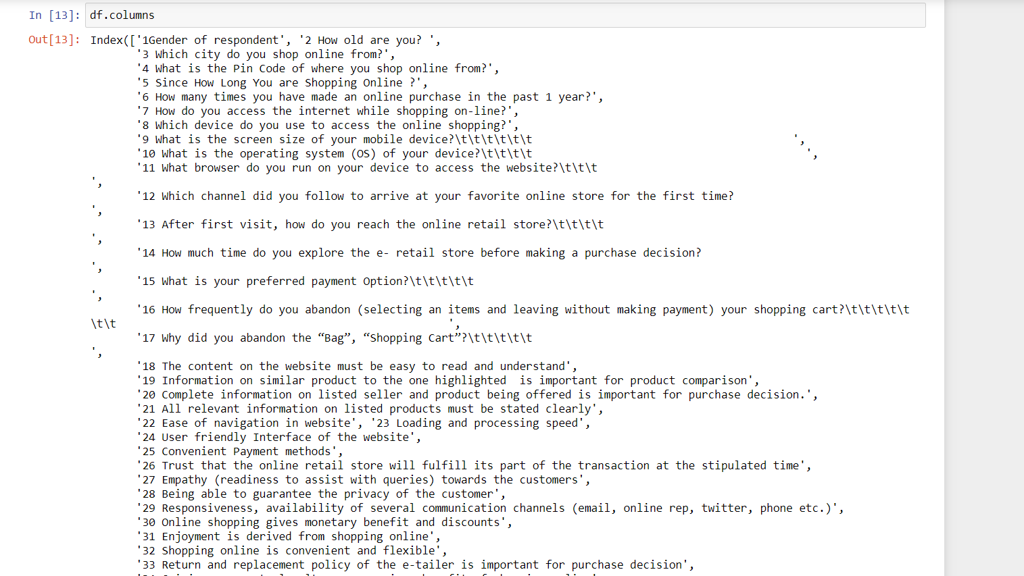

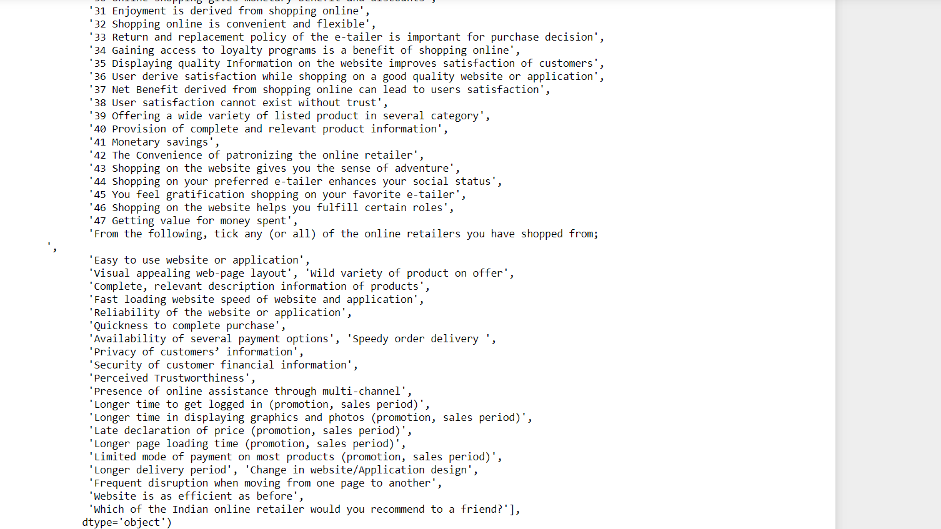

**Most of the customers who do online shopping are Females than males in terms of gender**

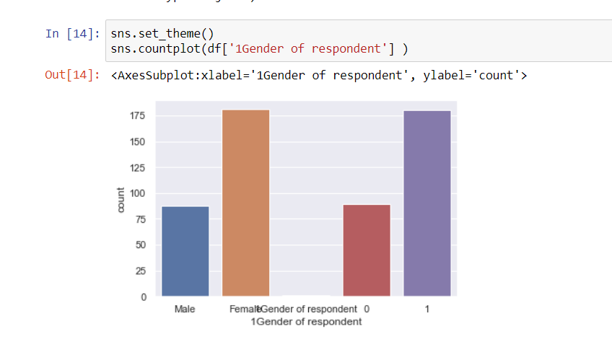

**As online shopping is in trends from 6-7 years, it is used to take time for the people to get familiar on the site which is very important. So as they are getting used to it the plot shows that most of the customers are actively using online shopping for>4years.** 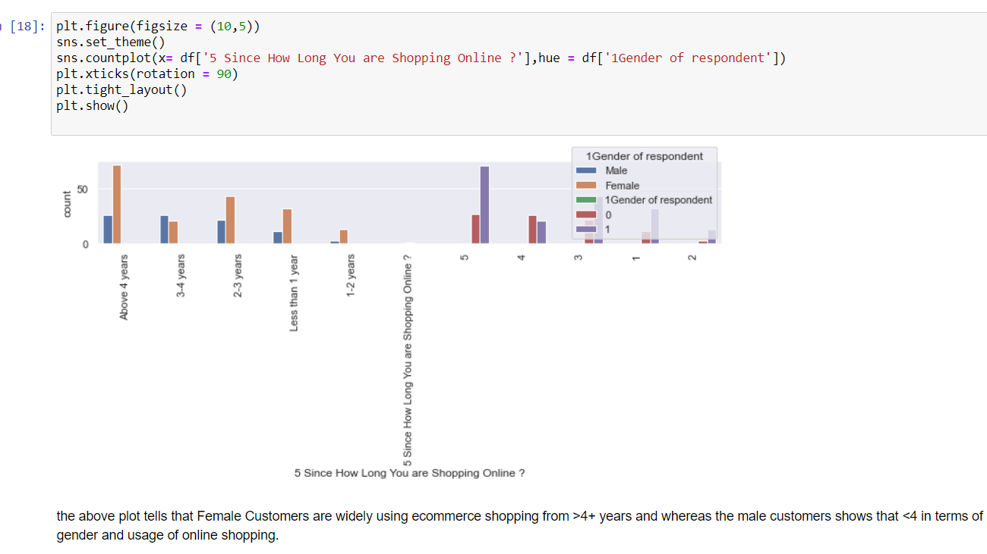

jkjfnrknkjnd

**Customers prefer to use smartphones than desktop or laptop for online shopping as it is easy to carry and flexible and user friendly.**

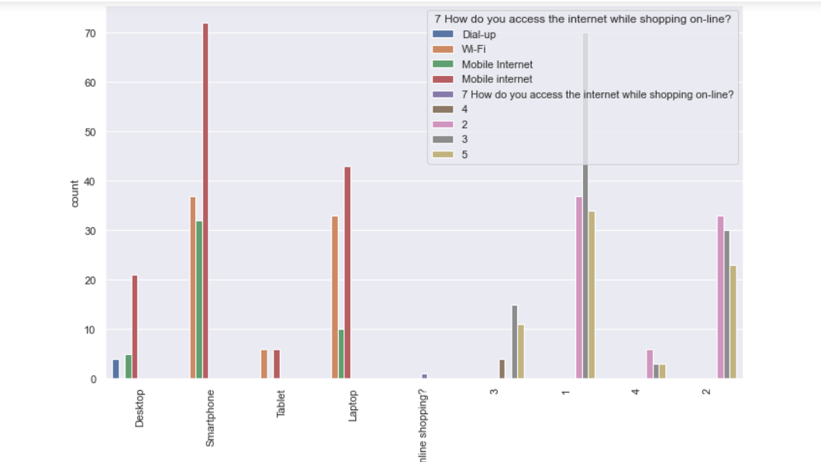

**While visiting the store, Customers are using search engine more than content and AD’s.**

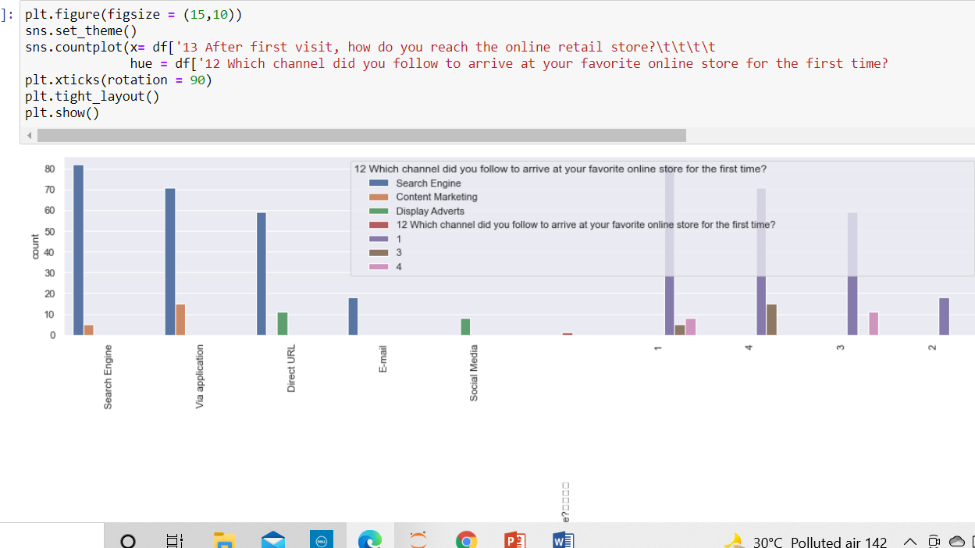

**Important thing is about payment and most of the customers preferred to pay online through credit/ debitcards and safe transaction as well ans COD as well .**

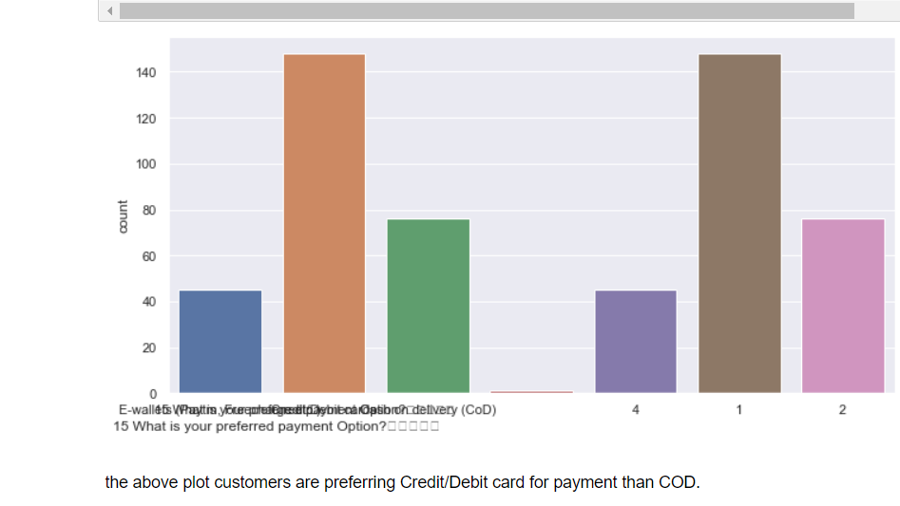

**CONCLUSION**

* Key Findings and Conclusions of the Study

In-order to retain the customer to back to the site, Websites should have easily accessible and limiting the process in Login/Register.

As most of the customers are females, Websites can spend a quality time on analytics to see what the customers has purchased often and their recently viewing items and how many items they have viewed that products etc.

Also to attract male customer, Website can give specific discount or offers to customers to retain them back.